1. Design DFA using simulator to accept the string having ‘abc’ as substring over the set {a,b,c}

INPUT:

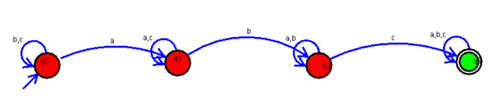

OUTPUT:

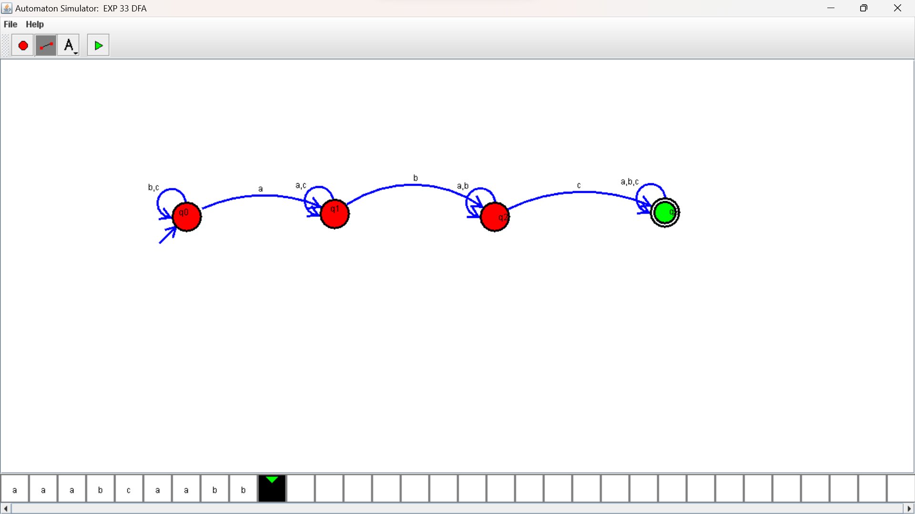

RESULTS:

DFA using simulator to accept the string having ‘abc’ as substring over the set {a,b,c}